EXECUTIVE PORTFOLIO  BRUCE  FRANSE  EXECUTIVE LEADERSHIP  The best organizations don't outperform because they have better people.  They outperform because they help good people make better decisions.  Building Organizational Capability  Sacramento, California | 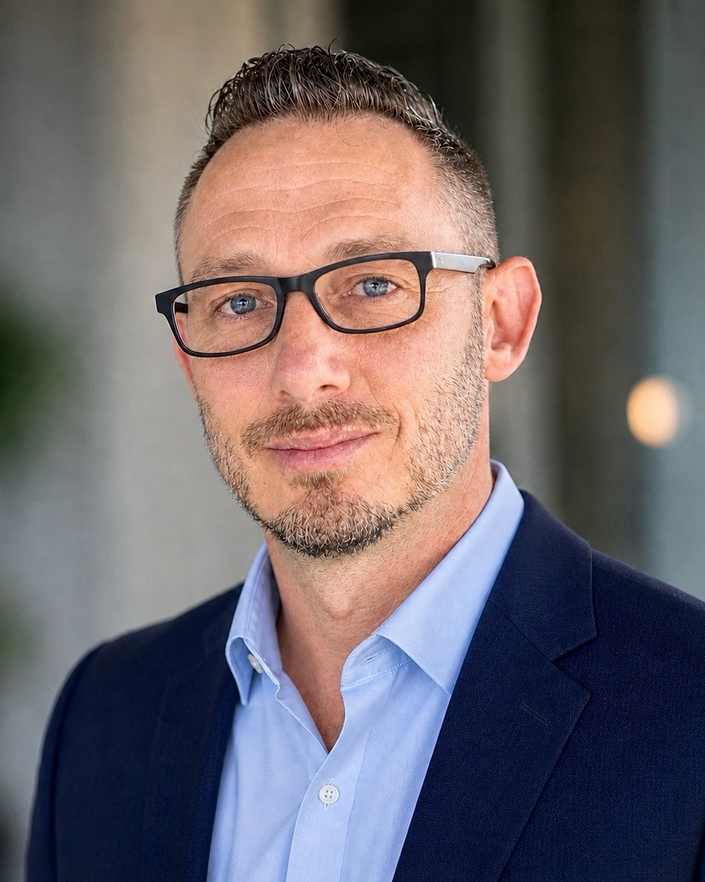

01

Perspective
“Revenue is the outcome. The work is building the organization that produces it.”
I've seen the same pattern repeat across manufacturing, industrial distribution, telecommunications, fitness, technology, and multi-site operations. The industries changed. The work didn't.
I have watched that pattern repeat across manufacturing, industrial distribution, telecommunications, fitness, technology, and multi-site operations. The industries changed. The work did not.
Commercial leadership became the way I learned the business. Every role exposed a different part of it: leadership, forecasting, operations, customers, and execution. Eventually they stopped feeling like separate conversations.
My career has included building a territory from the ground up, scaling a sales organization from three people to approximately forty, leading an $18 million multi-location business, managing a $40 million commercial portfolio, and rebuilding regional performance across the Western United States and Canada.
The common thread was never a product or industry. It was strengthening the organization behind the result.
20+  YEARS | $18M  BUSINESS UNIT | $40M  PORTFOLIO | 90+  PEOPLE LED | 2  COUNTRIES

02

Building Capability
Every role expanded the scope of my responsibility and the way I understood organizations.
BUSINESS FOUNDATION | MasterTile  Progressed through warehouse operations, management, purchasing, customer service, Territory Manager, and Senior Territory Manager. That foundation taught me how commercial decisions affect every part of a business.  Rebuilt the Bay Area from approximately $30K annually to more than $1.2M in the first full year.
ORGANIZATIONAL SCALE | SureWest Communications  Built separate Residential and Commercial organizations as the team grew from three representatives to approximately forty, led through four Sales Managers.  Growth exposed the need for leadership capacity, structure, forecasting, and clear accountability.
TALENT & RECRUITING | California Prime  Led fourteen Outside Sales Representatives in a demanding field-sales environment where recruiting and development were constant business requirements.  Learned to recognize character, coachability, and work ethic before potential became obvious on a resume.
EXECUTIVE OPERATIONS | California Family Fitness  Led the company’s largest Fitness business unit: approximately $18M, eight locations, and more than ninety employees.  Operations, finance, customer experience, leadership, and revenue became one connected conversation.
COMMERCIAL JUDGMENT | Cogent Solutions & Supplies  Managed a $40M industrial territory while increasing monthly gross profit from approximately $25K to $45K.  Healthy growth requires judgment: customer value, profitability, resources, and long-term relationships must reinforce one another.
REGIONAL LEADERSHIP | Vision Engineering  Led seven Regional Sales Executives, four Manufacturer Representatives, and a distributor network across the Western United States and Canada.  Alignment and consistency mattered more than authority across a geographically dispersed organization.
EXECUTIVE PARTNERSHIP | Mid Valley IT  Joined to develop business while partnering with ownership on forecasting, pipeline management, territory planning, and commercial structure.  The closer leadership gets to ownership, the more every conversation becomes about the business rather than the function.

03

Three Questions
When I am trying to understand a business, I keep coming back to three questions.
01 | Who makes decisions?  Strong organizations develop leaders throughout the business instead of creating dependence on one or two individuals. Leadership creates leverage when managers can coach, decide, and build capable teams of their own.  SureWest • California Family Fitness • Vision Engineering

02 | How are decisions made?  Forecasting, commercial discipline, and financial clarity should improve tomorrow’s decisions, not simply explain yesterday’s results. Better information matters only when it changes judgment and action.  California Family Fitness • Cogent • Vision Engineering

03 | Can the organization execute consistently?  Clear expectations, simple systems, and a disciplined operating rhythm allow good people to perform without constant intervention or extraordinary effort. Consistency compounds.  MasterTile • California Family Fitness • Mid Valley IT

Leadership, decision quality, and execution either reinforce one another or compete with one another. Strong organizations make sure they reinforce one another.

04

In Practice
Different industries. Different business models. The same responsibility: leave the organization more capable than it was before.
MASTERTILE
Building a business where one no longer existed.
CONTEXT | Multiple Bay Area branch closures left little existing business and required the territory to be rebuilt.
FOCUS | Learn the market, rebuild customer confidence, develop relationships, and create repeatable commercial execution.
OUTCOME | Annual revenue grew from approximately $30K to more than $1.2M during the first full year. The territory eventually supported three additional Territory Managers.

The assignment began as rebuilding revenue. It became a lesson in building the business behind it.

SUREWEST COMMUNICATIONS
Growth exposed leadership. Leadership enabled growth.
CONTEXT | A three-person operation was expanding quickly and needed structure that could scale with headcount.
FOCUS | Recruit continuously, develop managers, establish expectations, and shift leadership from individual performance to organizational capability.
OUTCOME | The organization grew to approximately forty sales professionals across Residential and Commercial teams, led through four Sales Managers.

Organizations do not scale because one leader works harder. They scale when leadership multiplies.

CALIFORNIA FAMILY FITNESS
Departments do not grow businesses. Organizations do.
CONTEXT | Lead the company’s largest Fitness business while improving consistency across eight locations.
FOCUS | Connect budgeting, forecasting, staffing, coaching, customer experience, and operating performance rather than treating them as separate conversations.
OUTCOME | Led an approximately $18M operation with more than ninety employees and about $6M in annual Personal Training revenue.

Forecasting stopped being a reporting exercise and became a leadership tool for building the next month before the current one ended.

04

In Practice — Continued
COGENT SOLUTIONS & SUPPLIES
Healthy growth requires judgment.
CONTEXT | Improve profitability inside a mature, price-sensitive industrial territory with a diverse customer base.
FOCUS | Understand the customer’s business, expand the right relationships, protect margin, and avoid treating every revenue opportunity as equally valuable.
OUTCOME | Managed a portfolio exceeding $40M while monthly gross profit increased from approximately $25K to $45K.

Revenue matters. The quality and durability of that revenue matter more.

VISION ENGINEERING
Consistency became the competitive advantage.
CONTEXT | Restore commercial stability across a region that had experienced extended turnover and inconsistent performance.
FOCUS | Align seven Regional Sales Executives, four Manufacturer Representatives, and distributors around forecasting, territory planning, account development, and coaching.
OUTCOME | Canadian revenue increased 17% while the Pacific Northwest increased 12%.

Authority mattered less than alignment. The region improved when expectations and execution became more consistent.

MID VALLEY IT
Commercial leadership works best when it is connected to ownership.
CONTEXT | Develop new business while helping ownership strengthen the commercial side of a growth-stage company.
FOCUS | Contribute to forecasting, pipeline management, territory planning, sales process, positioning, and the structure required for long-term growth.
OUTCOME | Built executive relationships across the Central Valley while helping connect immediate business development to broader commercial priorities.

The closer leadership gets to ownership, the more every conversation becomes about the business rather than the department.

05

At a Glance
20+  YEARS OF LEADERSHIP | $18M  LARGEST BUSINESS UNIT | $40M  COMMERCIAL PORTFOLIO
90+  EMPLOYEES LED | 8  MULTI-SITE LOCATIONS | 17%  REGIONAL GROWTH

BUSINESS SCOPE  - P&L and budget responsibility  - Multi-site operations  - Regional and cross-border leadership  - Direct, manufacturer-rep, and distributor channels  - Ownership and executive partnership | CORE CAPABILITIES  - Executive leadership  - Commercial strategy and revenue growth  - Forecasting and decision support  - Organizational and leadership development  - Operational execution and accountability  - Recruiting and talent development
Regional Scope
United States & Canada
8 States
Industry experience: manufacturing, industrial distribution, telecommunications, technology, building materials, and multi-site consumer services.

LOOKING AHEAD
The next chapter of my career is not about leading a larger sales organization.
It is about helping lead a stronger business.
I have spent my career learning how leadership, commercial judgment, operations, and execution work together. Different industries gave me different perspectives, but the work remained remarkably similar: develop capable people, make better decisions, and build organizations that can sustain growth.
That is the work I am looking forward to continuing.
BRUCE FRANSE
Sacramento, California | 916-289-1837 | Franse.Bruce@gmail.com
linkedin.com/in/brucefranse

Version 4.0 Design Notes Applied
Design direction for production:
• Cover subtitle updated to 'Building Stronger Organizations'.
• Page 7: redesign with three matching panels (Business Scope, What I Build, Operating Experience).
• Increase whitespace on Pages 3, 5 and 6.
• Reduce visual weight of Context/Focus/Outcome labels.
• Tighten typography hierarchy and spacing.
• Rewrite Page 8 ending with 'The industries changed. The work didn't.'

